Mini Project: Mya and Ahsan

## Frontend Documentation

### Repo: <https://bit.ly/miniProjectfrontend>

*Are they a Bot or Not?* Is a simple mobile application that lets a user submit a twitter handle to check and see if an account they follow is not real, a bot, or a real human, not! The app begins on a home screen that relays the utility of the app (*See Image 1*). The user will then click on “Click to find Bots” to enter into the action screen.

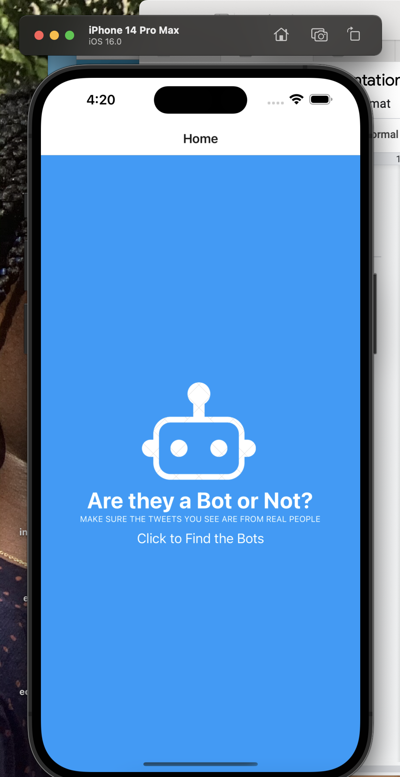

Image 1

A user will enter in the handle of the twitter account they want to find out more about. Please *see images 2 and 3.*

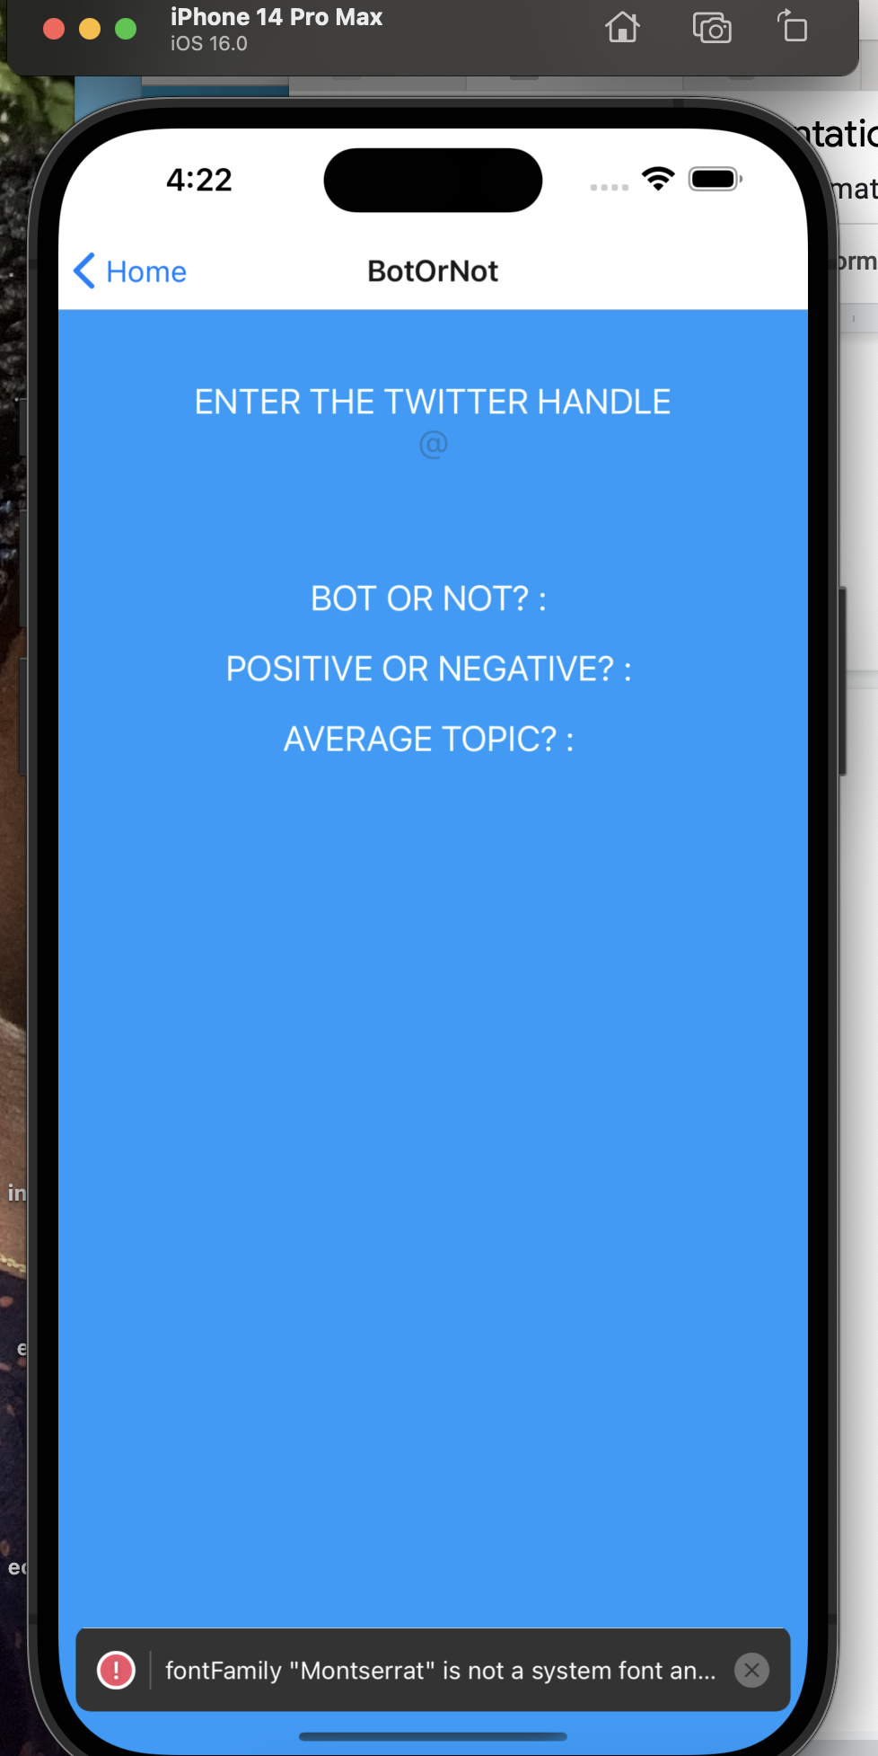

Image 2

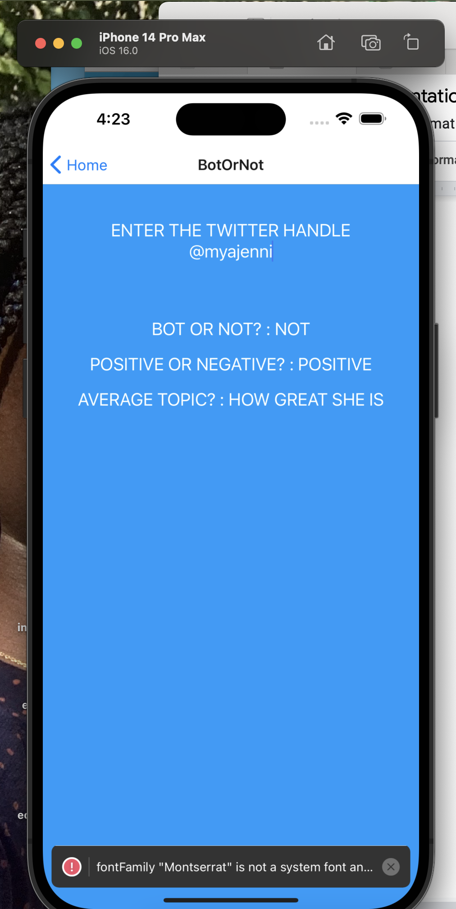

Image 3

Please note *Are they a Bot or Not?* Application engages user input to find out if a twitter account is real or not. The developers did not assume that the user follows the account they want to find out more information about. Please also consider that we were not able to connect the frontend to the backend of the application. The examples above are using fake data.

BACKEND DOCUMENTATION

* Tried using Google Cloud with Firebase however was having trouble with some authentication issues within tutorial
* More comfortable with AWS so switched over
  + Solution architecture involves using DynamoDB for twitter data storage, Lambda function dictating API calls and directing data to Dynamo, and REST APIs created using API Gateway to interact with user requests. At the time, the thought process was that we would go on to use React with AWS Amplify but opted to first demonstrate Twitter API functionality before preceding
* Wrote python function to pull related tweets of a keyword using tweepy library and was able to get it to work; given more time, would’ve been able to implement other functionalities such as bot detection.
* Example of search:

